*273/2*

*GEOGRAPHY*

*Paper 2*

*2½ hours*

**RESOURCEFULMOCKS 2019**

**UGANDA CERTIFICATE OF EDUCATION**

Uganda Certificate of Education

GEOGRAPHY

Paper 2

2 hours 30 minutes

INSTRUCTIONS TO CANDIDATES:

*Answer* **four** *questions in all.*

*Choose* **two***questions from part* **1***and* **two** *from Part* **II.**

*In part* **II,one** *question should be chosen from any* **one** *region.*

*Any additional question(s) answered will not be marked.*

PART I: THE REST OF AFRICA

Answer **two** questions from this part.

1. Study Figure 1 below showing the Volta river project and answer the questions that follow.

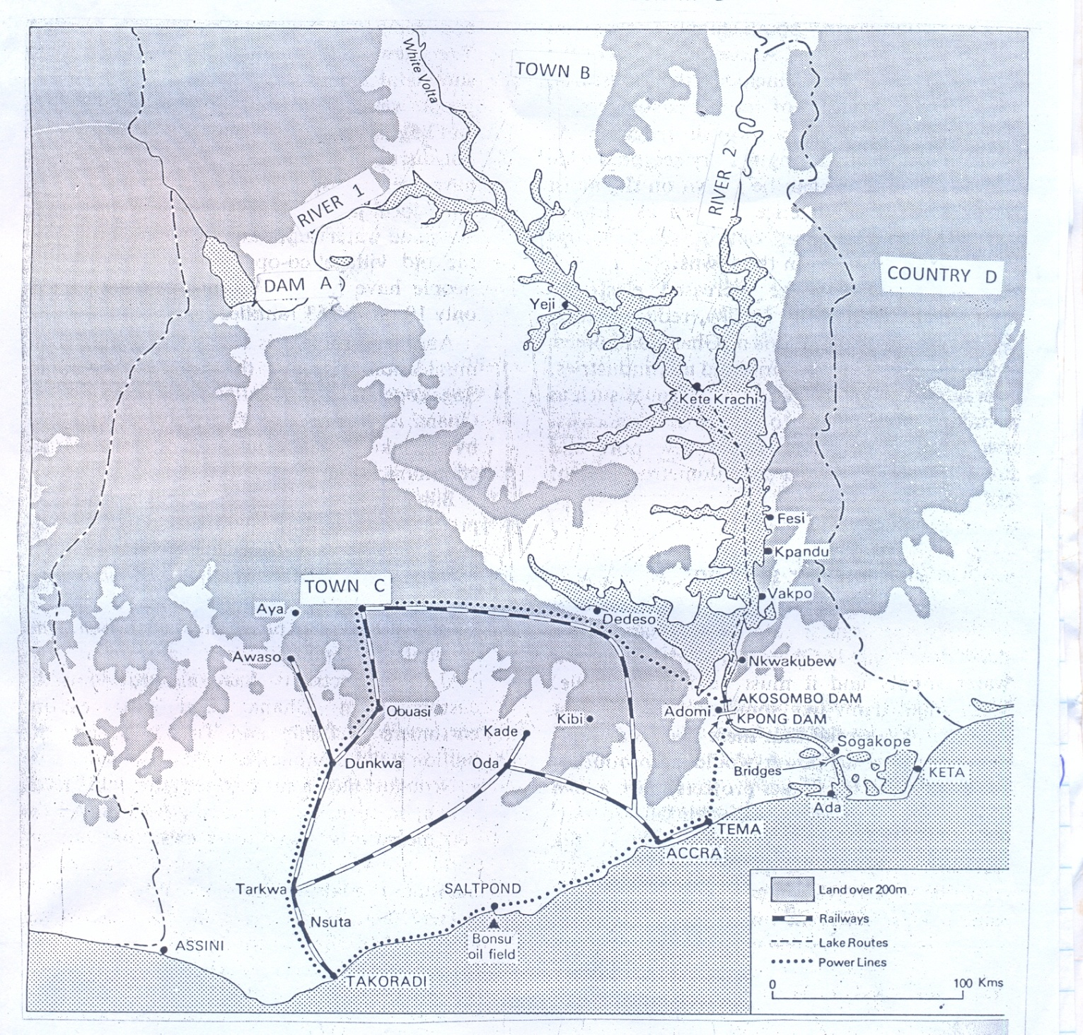

(a) Name the;

1. Rivers marked 1 and 2.
2. Dam marked A.
3. Towns marked B and C.
4. Neighbouring country marked D. (6 marks)

(b) Describe the physical conditions which favoured the establishment of the

Volta river project. (8 marks)

(c) Explain the benefits of the Volta river project to the people living in the area. (6 marks)

(d) Outline the effects of the establishment of the Volta river project on

the environment. (5 marks)

2. (a) Draw a sketchmap of Namibia and on it mark and name;

(i) ports: Walvis Bay and Luderitz.

(ii) water bodies Antlantic Ocean, Fish River and River Cubango.

(iii) Etosha pan.

1. Namib Desert. (8 marks)

(b) Describe the factors which have favoured extraction of marine resources

in Namibia. (8 marks)

(c) Explain the problems faced in the extraction on of marine resources in

Namibia. (6 marks)

(d) Outline the strategies that Namibia has undertaken to develop her fishing

sector. (3 marks)

3. Study table 1 below showing farming products from Republic of South Africa

(2010 – 2015) and answer the questions that follow.

|  |  |  |
| --- | --- | --- |
| **Year** | **‘000 metric tonnes** | **‘000 metric tonnes** |
| **Beef** | **Mutton** |
| 2010  2011  2012  2013  2014  2015 | 15,600  15,680  15,770  16,130  16,100  16,000 | 33,680  38,650  43,030  46,330  47,790  49,730 |

1. Draw a bar graph to show the trend of mutton production in Republic of

South Africa. (8 marks)

1. Calculate the percentage change in;
2. Beef
3. Mutton production shown

in the table between 2013 and 2015. (2 marks)

1. Describe the; (3 marks)
2. human factors which have favoured livestock farming in Republic

of South Africa. (6 marks)

1. values of livestock farming to the development of Republic of South

Africa. (6 marks)

1. State any three breeds of sheep or cattle reared in Republic of South Africa. (3 marks)

4. Study Figure 2: Map of Swaziland below and answer the questions that follow.

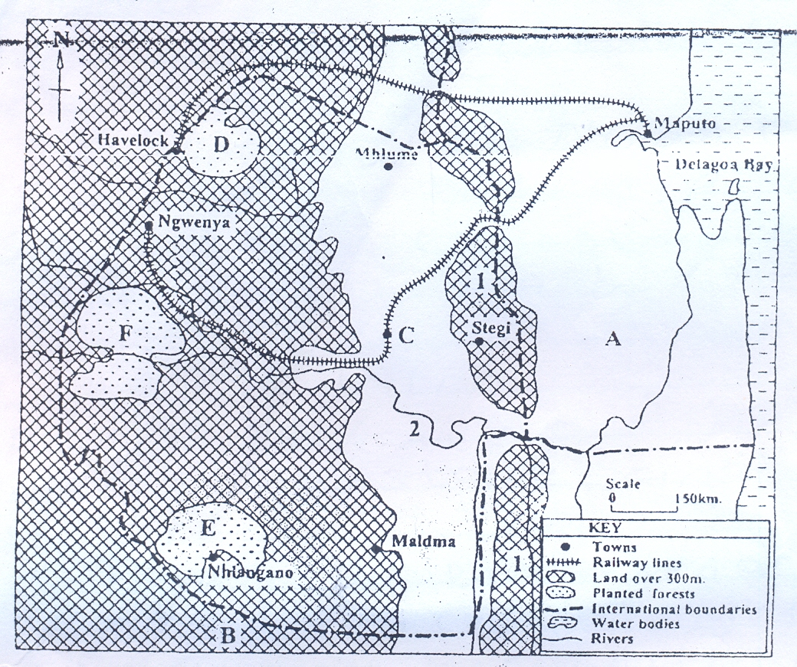

***Fig. 2:***

1. Name the;
2. Escarpment marked 1.
3. river marked 2.
4. countries marked A and B.
5. town marked C.
6. forests marked D, E and F. (8 marks)
7. (i) Identify two tree species felled in Swaziland. (2 marks)
8. Describe the physical conditions which have promoted the development

of the forestry sector in Swaziland. (6 marks)

1. Outline the problems faced by the forestry sector in Swaziland. (5 marks)
2. Outline the measures that should be taken to improve the forestry sector in Swaziland. (4 marks)

PART II: STUDIES IN DEVELOPMENT

*Answer two questions from this part.*

REGION I: NORTH AMERICA

5. (a) Draw a sketchmap of St. Lawrence Seaway and on it mark and name;

(i) Lake Ontario

(ii) River Ottawa

1. Towns Kingstone and Quebec.
2. Canals Masena and Beauharnols. (7 marks)

(b) Explain the obstacles to navigation before the construction of St. Lawrence

Seaway. (6 marks)

1. How were the obstacles in 5(b) above overcome? (6 marks)

(d) Outline the benefits of St. Lawrence sea way to the development of the region.

(6 marks)

6. Study Figure 3: A sketchmap of Canada provided below and answer the questions

that follow.

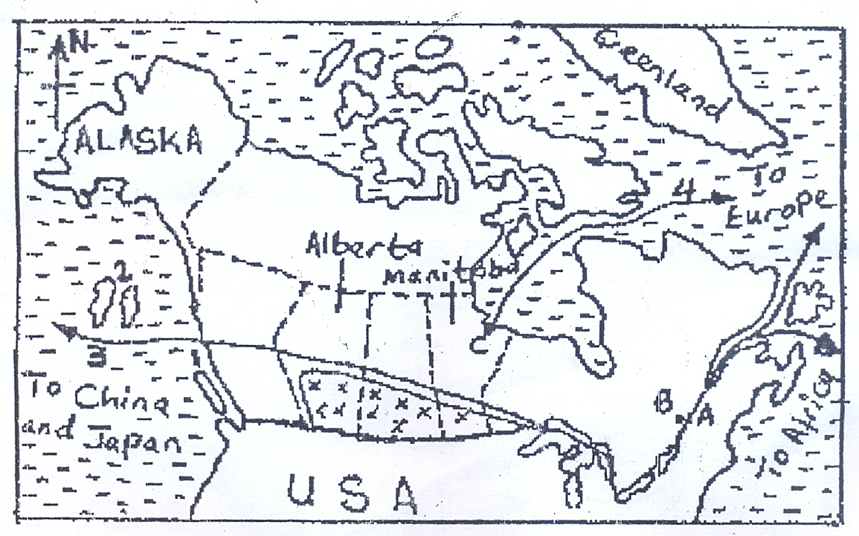

***Fig.3***

1. Name the;
2. river marked A.
3. ports marked B and C.
4. islands marked 1 and 2.
5. wheat export routes marked 3 and 4. (7 marks)
6. Outline the advantages associated with the Eastern and Northern export routes.

(5 marks)

1. Describe the physical factors that have favoured wheat growing in the

Canadian Prairies. (6 marks)

1. Outline the problems arising out of extensive wheat growing in Canada. (6 marks)

7. (a) Name any two;

(i) States

(ii) Industrial towns,

1. Industrial products in New England. (6 marks)

(b) Describe the factors which have favored the development of the

manufacturing industries in New England. (8 marks)

(c) Explain the effects of the manufacturing sector on the environment in

New England. (6 marks)

(d) What steps are being taken to improve the manufacturing sector in

New England? (5 marks)

REGION II: RHINELANDS

8. (a) Draw a sketchmap showing the Zuider Zee polders and on it mark and

name;

(i) North sea,

(ii) North Sea canal

(iii) River Yssel

1. North West polder, East polder and South polder. (7 marks)

(b) Describe the process of land reclamation in the Netherlands. (6 marks)

1. Explain the environmental problems which resulted from land reclamation

in the Netherlands. (8 marks)

(d) Outline the measures that were taken to combat the problems in 8(c) above. (4 marks)

9. Study Table II below showing the movement of ships on the Rhine water way between Basel and Rotterdam (2013 – 2018 projected) and answer the questions that follow.

Table II

|  |  |
| --- | --- |
| **Year** | **Number of ships** |
| 2013  2014  2015  2016  2017  2018 | 104,000  112,000  126,000  128,000  129,200  141,000 (projected) |

1. Draw a line graph to show the flow of ships on the Rhine waterway

indicated in the table above. (8 marks)

(b) Describe the factors which have led to the development of the

Rhine waterway. (6marks)

(c) Explain the problems faced by countries using the Rhine waterway.

(6 marks)

(d) Outline the measures being taken to solve the problems in a(c) above.

**(5 marks)**

10. Study Figure 4 below showing the position of Basel in Switzerland and answer the questions that follow.

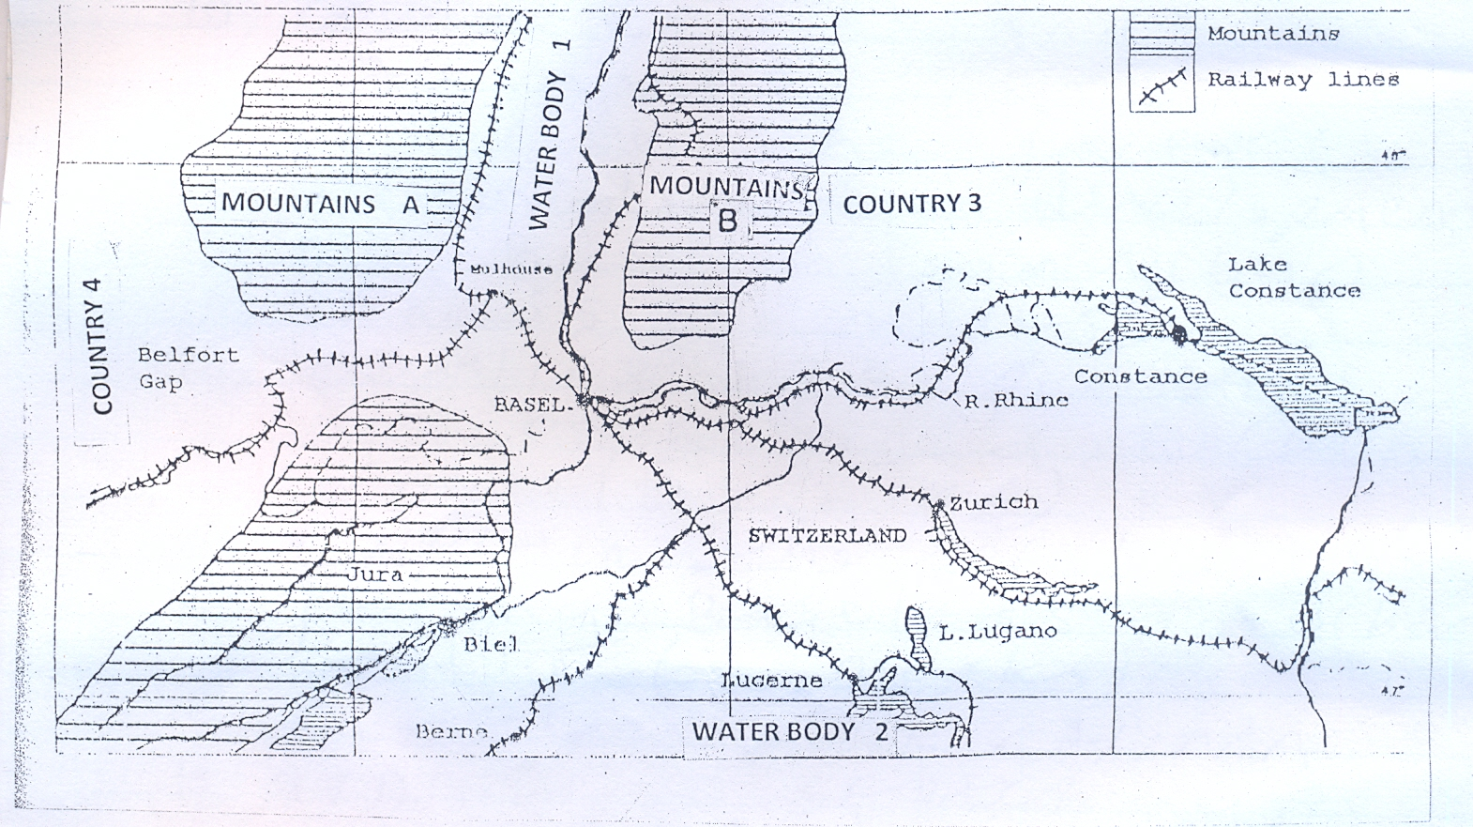

1. Name the;
2. mountains A and B,
3. waterbodies 1 and 2,
4. countries 3 and 4. (6 marks)
5. Describe the factors that led to development of Basel as an urban centre.

(8 marks)

(c) Outline the functions of Basel as an urban centre. (5 marks)

(d) Explain the problems facing Basel as an urban centre. (6 marks)

REGION III: CHINA

11. (a) Draw a sketchmap of Manchuria industrial region and on it mark and name; (i) industrial towns: Dairen Antung and Harbin

(ii) Penki coal mining centre,

(iii) Iron ore mining centres: Fushun, Sian and Pehpiao. (8 marks)

(b) Describe the factors responsible for the concentration of industries in

any one industrial centre. (8marks)

1. Outline the effects of industrial development on the physical environment

in Manchuria. (5 marks)

1. State three countries where China exports her industrial products. (3 marks)

12. Study Table III below showing Bauxite production in selected areas of China in 2014

and answer the questions that follow.

**Table III**

|  |  |
| --- | --- |
| **Area** | **Production 000’ metric tons** |
| Shandong  Dantong  Shanxi  Fushun  Shenyang  Henan | 34,207  16,282  8750  7,702  4,600  3,459 |
| **Total** | **75,000** |

(a) Draw a pie-chart to show Bauxite production in China. (12 marks)

1. Describe the conditions favouring the growth of the mining sector in

China. (6 marks)

1. Outline the effects of the mining sector on the physical environment in

in China. (5 marks)

1. State any other two minerals exploited in China. (2 marks)

13. Study Figure 5: Map of the Yangtse delta region and answer the questions which follow.

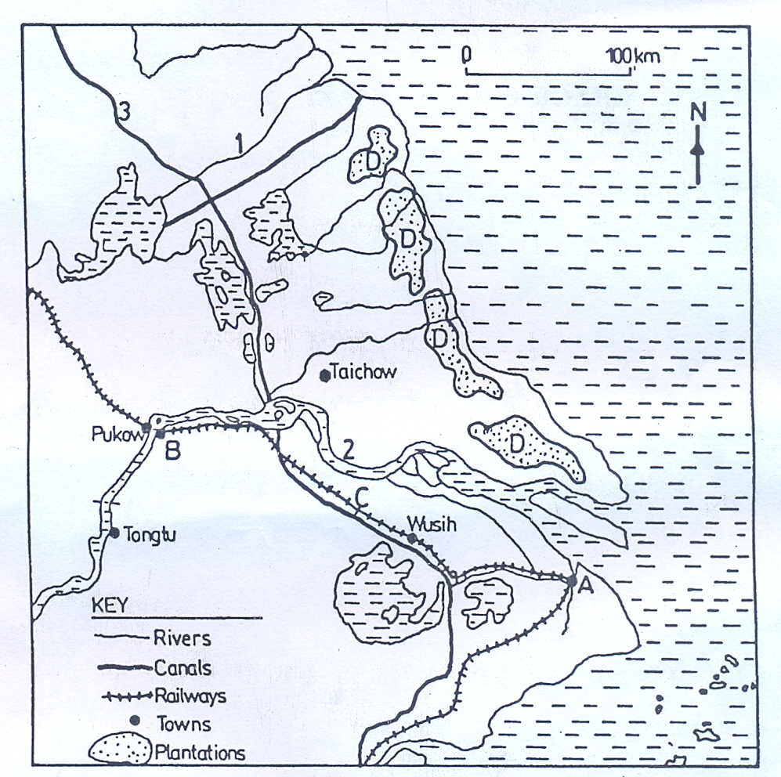

***Fig.5***

1. Name the;
2. rivers marked 1 and 2.
3. canal marked 3.
4. town marked A and B.
5. railway line marked C.
6. plantation crop grown in areas marked D. (7 marks)
7. Describe the factors which have favoured agriculture in the Yangtse delta

region. (8 marks)

1. Explain the contribution of agriculture to the development of the Yangtse

delta region. (6 marks)

1. Outline the problems faced by farmers in the Yangtse delta region. (4 marks)

END